LTC API Document
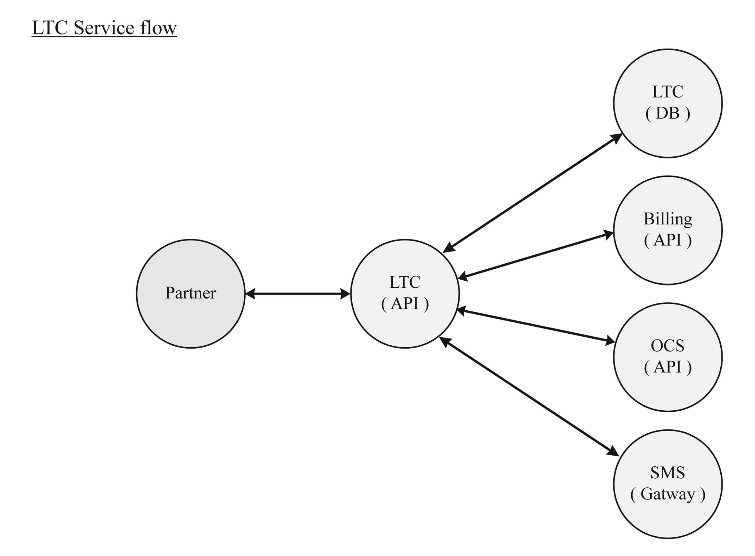
Private URL: http://172.28.12.44:5678/Services.asmx?WSDL
Public URL: http://ltcservice.laotel.com:5678/Services.asmx?WSDL

Parameter Name
name | type | Description
type | string(10) | 0=1postpaid; 1=pstn; 2 internet(ADSL,Leadlind,FTH); 3=prepaid(Topup)
msisdn | string(15) | phone number or user internet
amount | long | money amount for pay
user_id | string(10) | user id for partner
trans_id | string(20) | transuction id primerykey(running number)
message | string(320) | message send to customer
header | string(10) | header for send sms
startDate | date | Start date for finding (DD-MMM-YYYY)
endDate | date | End date for finding (DD-MMM-YYYY)
key | string(max) | Ncrypt data Exg : data = (type+msisdn+amount+user_id+trans_id) key = ltc.srv.com.ltc.encrypt(data,privateKey)

Remark: Prepaid number is M-Phone, W-Phone and HSPA or NetSim.

Response Code
resultCode | resultDesc
01 | 01 Incorrect key.
02 | 02 Incorrect msisdn.
03 | 03 Cannot insert transuction log.
04 | 04 Dupicate transuction.
06 | 06 Incorrect user_id or user_pass.
07 | 07 Incorrect Product type.
08 | 08 user id xx is not open service.
09 | 09 amount is between 5000 and 500000 only.
10 | 10 Incorrect sim master.
11 | 11 Balance sim master is less than amount
12 | 12 Can not 2echar balance sim master.
13 | 13 Transuction is canceled already.
14 | 14 Transuction is not found.
15 | 15 Transuction can not cancel.
20 | 20 Operation 2successsede2.
21 | 21 Cannot 2recharge money to OCS.
31 | 31 Cannot payment to billing (BSS).
40 | 40 Error exception.
41 | 41 Please correct parameter.
42 | 42 Please correct parameter less than 10.
43 | 43 Please correct amount is number only.

File dll for .Net 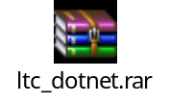

File class for Java 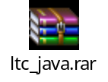

- Function CheckBalance
Request
<?xml version="1.0" encoding="utf-8"?>
<soap:Envelope xmlns:xsi="http://www.w3.org/2001/XMLSchema-instance" xmlns:xsd="http://www.w3.org/2001/XMLSchema" xmlns:soap="http://schemas.xmlsoap.org/soap/envelope/">
<soap:Body>
<CheckBalance xmlns="http://ltcservice.laotel.com">
<type>string</type>
<msisdn>string</msisdn>
<user_id>string</user_id>
<key>= ltc.srv.com.ltc.encrypt((type+msisdn+user_id),privateKey)</key>
</CheckBalance>
</soap:Body>
</soap:Envelope>
Response
<?xml version="1.0" encoding="utf-8"?>
<soap:Envelope xmlns:xsi="http://www.w3.org/2001/XMLSchema-instance" xmlns:xsd="http://www.w3.org/2001/XMLSchema" xmlns:soap="http://schemas.xmlsoap.org/soap/envelope/">
<soap:Body>
<CheckBalanceResponse xmlns="http://ltcservice.laotel.com">
<CheckBalanceResult>
<resultCode>string</resultCode>
<resultDesc>string</resultDesc>
<response>string</response>
<balance>long</balance>
</CheckBalanceResult>
</CheckBalanceResponse>
</soap:Body>
</soap:Envelope>
- Function CheckBalanceCenter
Request
<?xml version="1.0" encoding="utf-8"?>
<soap:Envelope xmlns:xsi="http://www.w3.org/2001/XMLSchema-instance" xmlns:xsd="http://www.w3.org/2001/XMLSchema" xmlns:soap="http://schemas.xmlsoap.org/soap/envelope/">
<soap:Body>
<CheckBalanceCenter xmlns="http://ltcservice.laotel.com">
<user_id>string</user_id>
<key> ltc.srv.com.ltc.encrypt(user_id,privateKey)</key>
</CheckBalanceCenter>
</soap:Body>
</soap:Envelope>

Response
<?xml version="1.0" encoding="utf-8"?>
<soap:Envelope xmlns:xsi="http://www.w3.org/2001/XMLSchema-instance" xmlns:xsd="http://www.w3.org/2001/XMLSchema" xmlns:soap="http://schemas.xmlsoap.org/soap/envelope/">
<soap:Body>
<CheckBalanceCenterResponse xmlns="http://ltcservice.laotel.com">
<CheckBalanceCenterResult>
<resultCode>string</resultCode>
<resultDesc>string</resultDesc>
<response>string</response>
<balance>long</balance>
</CheckBalanceCenterResult>
</CheckBalanceCenterResponse>
</soap:Body>
</soap:Envelope>
- Function Topup
Request
<?xml version="1.0" encoding="utf-8"?>
<soap:Envelope xmlns:xsi="http://www.w3.org/2001/XMLSchema-instance" xmlns:xsd="http://www.w3.org/2001/XMLSchema" xmlns:soap="http://schemas.xmlsoap.org/soap/envelope/">
<soap:Body>
<Topup xmlns="http://ltcservice.laotel.com">
<msisdn>string</msisdn>
<amount>string</amount>
<user_id>string</user_id>
<trans_id>string</trans_id>
<key> ltc.srv.com.ltc.encrypt((msisdn+amount+user_id+trans_id),privateKey)</key>
</Topup>
</soap:Body>
</soap:Envelope>
Response
<?xml version="1.0" encoding="utf-8"?>
<soap:Envelope xmlns:xsi="http://www.w3.org/2001/XMLSchema-instance" xmlns:xsd="http://www.w3.org/2001/XMLSchema" xmlns:soap="http://schemas.xmlsoap.org/soap/envelope/">
<soap:Body>
<TopupResponse xmlns="http://ltcservice.laotel.com">
<TopupResult>
<resultCode>string</resultCode>
<resultDesc>string</resultDesc>
<msisdn>string</msisdn>
<receipt>string</receipt>
<amount>long</amount>
<user_id>string</user_id>
</TopupResult>
</TopupResponse>
</soap:Body>
</soap:Envelope>

- Function Payment
Request
<?xml version="1.0" encoding="utf-8"?>
<soap:Envelope xmlns:xsi="http://www.w3.org/2001/XMLSchema-instance" xmlns:xsd="http://www.w3.org/2001/XMLSchema" xmlns:soap="http://schemas.xmlsoap.org/soap/envelope/">
<soap:Body>
<Payment xmlns="http://ltcservice.laotel.com">
<type>string</type>
<msisdn>string</msisdn>
<amount>string</amount>
<user_id>string</user_id>
<trans_id>string</trans_id>
<key> ltc.srv.com.ltc.encrypt((type+msisdn+amount+user_id+trans_id),privateKey)</key>
</Payment>
</soap:Body>
</soap:Envelope>
Response
<?xml version="1.0" encoding="utf-8"?>
<soap:Envelope xmlns:xsi="http://www.w3.org/2001/XMLSchema-instance" xmlns:xsd="http://www.w3.org/2001/XMLSchema" xmlns:soap="http://schemas.xmlsoap.org/soap/envelope/">
<soap:Body>
<PaymentResponse xmlns="http://ltcservice.laotel.com">
<PaymentResult>
<resultCode>string</resultCode>
<resultDesc>string</resultDesc>
<msisdn>string</msisdn>
<receipt>string</receipt>
<amount>long</amount>
<user_id>string</user_id>
</PaymentResult>
</PaymentResponse>
</soap:Body>
</soap:Envelope>

- Function SendSMS
Request
<?xml version="1.0" encoding="utf-8"?>
<soap:Envelope xmlns:xsi="http://www.w3.org/2001/XMLSchema-instance" xmlns:xsd="http://www.w3.org/2001/XMLSchema" xmlns:soap="http://schemas.xmlsoap.org/soap/envelope/">
<soap:Body>
<SendSMS xmlns="http://ltcservice.laotel.com">
<msisdn>string</msisdn>
<message>string</message>
<user_id>string</user_id>
<header>string</header>
<key> ltc.srv.com.ltc.encrypt((msisdn+message+user_id+header),privateKey)</key>
</SendSMS>
</soap:Body>
</soap:Envelope>
Response
<?xml version="1.0" encoding="utf-8"?>
<soap:Envelope xmlns:xsi="http://www.w3.org/2001/XMLSchema-instance" xmlns:xsd="http://www.w3.org/2001/XMLSchema" xmlns:soap="http://schemas.xmlsoap.org/soap/envelope/">
<soap:Body>
<SendSMSResponse xmlns="http://ltcservice.laotel.com">
<SendSMSResult>
<resultCode>string</resultCode>
<resultDesc>string</resultDesc>
<msisdn>string</msisdn>
<receipt>string</receipt>
<user_id>string</user_id>
</SendSMSResult>
</SendSMSResponse>
</soap:Body>
</soap:Envelope>

- Function queryDetail
Request
<?xml version="1.0" encoding="utf-8"?>
<soap:Envelope xmlns:xsi="http://www.w3.org/2001/XMLSchema-instance" xmlns:xsd="http://www.w3.org/2001/XMLSchema" xmlns:soap="http://schemas.xmlsoap.org/soap/envelope/">
<soap:Body>
<queryDetail xmlns="http://ltcservice.laotel.com">
<type>string</type>
<startDate>date</startDate>
<endDate>date</endDate>
<user_id>string</user_id>
<key> ltc.srv.com.ltc.encrypt((type+user_id),privateKey)</key>
</queryDetail>
</soap:Body>
</soap:Envelope>
Response
<?xml version="1.0" encoding="utf-8"?>
<soap:Envelope xmlns:xsi="http://www.w3.org/2001/XMLSchema-instance" xmlns:xsd="http://www.w3.org/2001/XMLSchema" xmlns:soap="http://schemas.xmlsoap.org/soap/envelope/">
<soap:Body>
<queryDetailResponse xmlns="http://ltcservice.laotel.com">
<queryDetailResult>
<resultCode>string</resultCode>
<resultDesc>string</resultDesc>
<detail>
<recordDetail>
<trans_id>string</trans_id>
<type>int</type>
<msisdn>string</msisdn>
<amount>long</amount>
<record_date>dateTime</record_date>
<payment_id>string</payment_id>
<receipt_no>string</receipt_no>
</recordDetail>
<recordDetail>
<trans_id>string</trans_id>
<type>int</type>
<msisdn>string</msisdn>
<amount>long</amount>
<record_date>dateTime</record_date>
<payment_id>string</payment_id>
<receipt_no>string</receipt_no>
</recordDetail>
</detail>
</queryDetailResult>
</queryDetailResponse>
</soap:Body>
</soap:Envelope>

